

**This project “Student Information System” provides us a simple**

**Interface for maintenance of student information. It can be**

**used by educational institutes or colleges to maintain the**

**records of students easily. Achieving this objective is difficult**

**using a manual system as the information is scattered, can be**

**redundant and collecting relevant information may be very**

**time consuming. All these problems are solved using this**

**project. Throughout the project the focus has been on**

**presenting information in an easy and intelligible manner.**

**STUDENT INFORMATION SYSTEM**

**THIS PROJECT WAS TAKEN BY GROUP 12:**

**Sanjana Lakkimsetty AP21110010685**

**Yaswanth Sriram Jayyavarapu AP21110010686**

**Prasannakumar Jetti AP21110010687**

**PROJECT MENTOR: Prof.Usha Rani.R**

**ALGORITHM:**

Step 1: START

Step 2: Display of University name

Step 3: Display of MENU

Step 4: Menu is divided into four segments

Search for a student

View student record

Add student record

Delete student record

Back

Step 5: when we choose A which is search for a student by entering the giving unique ID it prints the details of a particular student

Step 6: when we choose B which is view student record, All the students present in the university list will appear

Step 7: when we choose C which is Add student record, this is to add new student’s details

Step 8: when we choose D which is Delete student record, this function is to delete the student record for the given Unique ID

Step 9: when we choose E which is BACK, this will end the program

Step 10: STOP

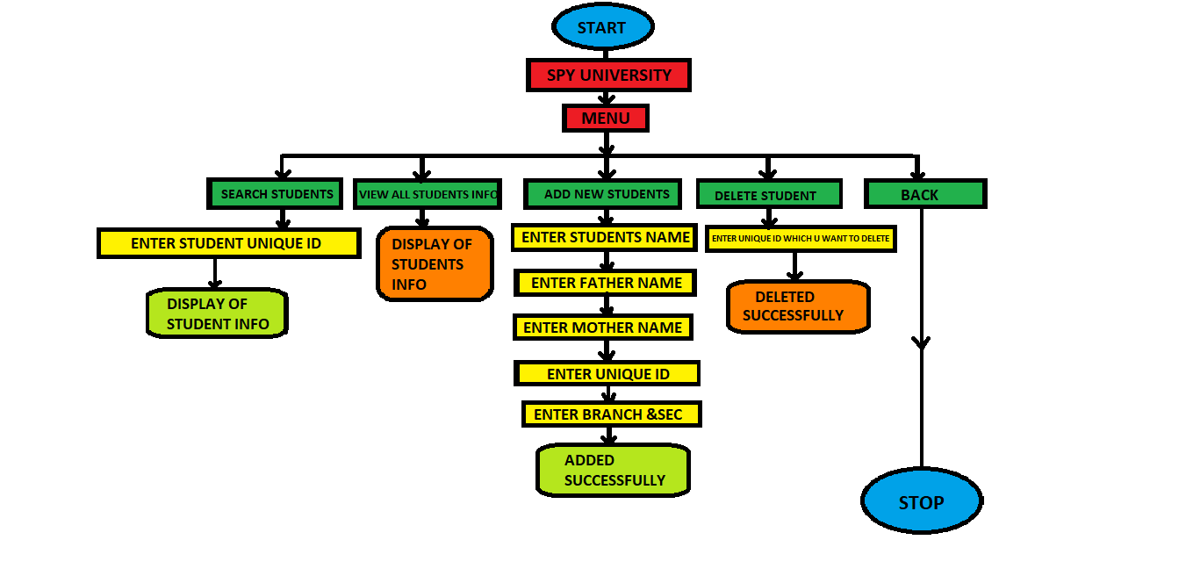**FLOWCHART:**

**THANK YOU**